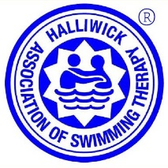

AGREEMENT AS TO TRANSLATION/REPRODUCTION OF HALLIWICK ASSOCIATION OF SWIMMING THERAPY MATERIALS

This agreement is between (the parties):

(1) The Halliwick Association of Swimming Therapy (Halliwick AST)
(undersigned by a representative):
Signature:

PRINT name:

Date:

Address:

And

(2) The individual/organisation who is requesting permission to translate/reproduce Halliwick AST material (undersigned by a representative):
Signature:

PRINT name:

Organisation:

Date:

Address (include Postal/Zip Code and Country):

Email address:

Material to be translated and/or reproduced (Please list all material you intend translating/reproducing):

The above signatories to this agreement (the parties) agree that translation and/or reproduction of Halliwick AST material shall be only in accordance with Halliwick AST’s Policy on Translation & Reproduction of Halliwick AST Material applying at the date this agreement is signed, and that material shall not otherwise be translated or reproduced.

On completion of section (2) above, please email the completed form to educsec.halliwickast@outlook.com for approval and, if agreed, countersignature. A countersigned copy will then be returned to you for your records.
We are unable to agree to your request to translate/reproduce material without a completed and signed form.

